CCATCH – Langstone Community Meeting

1st July 2013 19:00am – 21:00pm

Meeting report

Introduction

The meeting, held at the Langstone Sailing Club and hosted by the CCATCH the Solent Project (www.solentforum.org/current/CCATCH/) was attended by 38 members of the local community and stakeholders from organisations who have a role in flood prevention.

This report aims to capture the essence of the discussion and is not meant to be a formal minute of the meeting.

Session 1: Welcome & Introductions

Mike King (CCATCH Project ) welcomed people to the meeting and set the scene in the following way:

What is this meeting about?

- Introduce the CCATCH project to the community
- Developing a shared understanding of local flood risk and how that might change in the future.
- Tap into local knowledge to inform next steps.

What we intended to cover?

Part 1: Presentations
- Introducing the CCATCH project
- The changing nature of flood risk

Part 2: Participation
- Sharing understanding for local flood risk
- Identifying how the CCATCH project can help local people

Session 2: Introduction to the CCATCH project

Mike introduced the CCATCH project covering the following points:
- Explained that the project is part of a wider European project called CC2150 (Coastal Change in the year 2150 and beyond)
- That the UK (Hampshire, Kent and Sussex), Netherlands & Belgium are involved
- 6 locations in Hampshire have been chosen of which Southampton Itchen is one
- The Aim of CCATCH to is help the community prepare and adapt to changes in flood risk
- An outline of how the CCATCH project would like to work with the community

A copy of the full presentation accompanies this report.

Questions followed this presentation as follows:

Q: How does this relate to previous events, e.g. meetings with Environment Agency? Why go through exercise again?
A: Previous process was about getting foundations in place. North Solent Shoreline Management Plan and Coastal Strategy have informed the ‘hold the line’ policy, which is now with Local Authorities for practical implementation. We are now in a good place to move forward on a more practical level.

Q: Are we going to get more detail?
A: This is the first community meeting. This is opportunity for the community to get involved and share local knowledge. CCATCH is also an opportunity to share learning across sites and from other European CC2150 partners.

Q: Do people in Europe have more experience?
A: Yes, certainly in Holland. However, in Holland there is a top-down approach and little tradition of community engagement whereas community engagement is not unusual in the UK.

Q: Only small number of people in this room are directly affected by flooding. Are you going to present real data? That should be done before you ask us to share our experiences.. You should present us with really good data.
A: The second presentation this evening will help to address this issue.

Session 3: Local Perspectives

The participants were then invited to break into 3 groups to discuss the flood risk from their own perspective. Each group had a map on which they were asked to indicate/locate particular flood risk issues and/ or experiences. Each group worked with a facilitator.

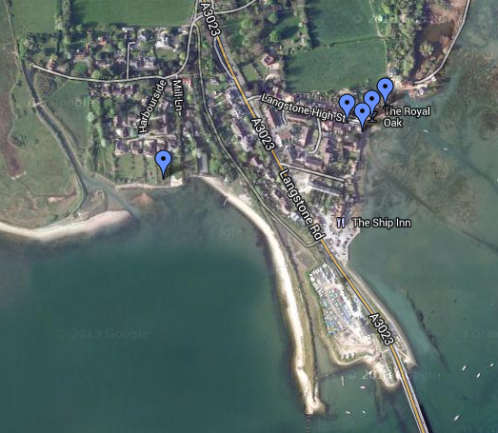
Point 1: Water has been thigh deep behind the pub, flood twice in two years, house owners are not always there.
Point 2: No car park at the Royal Oak pub, cars park in the High street even on high tides.
Point 3: High Street residents - knowledge of high tides and weather. Use sandbags and various forms of barrier. Some residents have permanent barriers. Waders and wellies essential.
Point 4: Holiday cottages on right hand side of the High Street are more vulnerable to flooding, not always someone there to respond.
Point 5: Garden Wall forms the barrier to flood water. Been flooded twice in 25 yrs.

Other matters raised by the groups
Flooding occurs because of a combination of high tide, low pressure and direction of wind.
A community sandbag store would be helpful, clarify if sandbags can be provided by Havant BC.
Very high insurance premiums in this area. Once you provide postcode the insurers often raise premiums substantially.
Table felt that a community flood plan would be of great use to the community.
Car parking a real issue related to the Royal Oak & Ship Inn. People use Langstone High Street – need to raise awareness.
Very helpful community, those not at risk help those who are during a flood.
Community sandbags and waders would be useful.

Table 1: Facilitator
Scott Mills
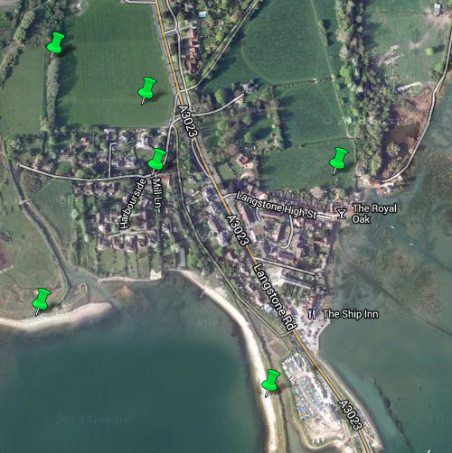
Point 1: Holes in defences periodically.

Point 2: Historic Field Flooding.

Point 3: No memory of flooding in this part of Mill Lane.

Point 4: Surface water flooding after heavy rain due to field run off.

Point 5: Rubbish in river from upstream may cause blockage.

Point 6: Erosion of shingle bank - improvements to Billy Line might provide a funding opportunity.
Table 3 Facilitator
James Addicot
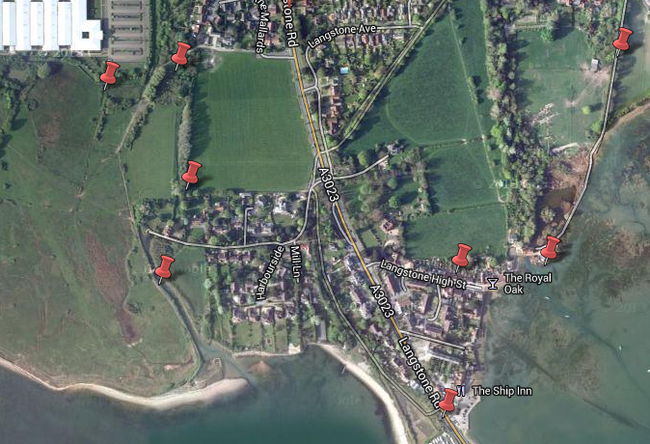
Point 1: Concerned that Lavant Stream might burst its banks in the future.
Point 2: Southmoor Fields have flooded up to this point in the past.
Point 3: Just before WW2 it flooded over the road and that is why the road was raised.
Point 4: Flood Response on the High Street. Properties north of the High Street have flood boards which they use when it is going to flood. Flood gate between two properties. Sandbags & Flood boards.
Point 5: Lavant Stream - flow appears to be controlled by sluice gates, unclear about who operates them and why.
Point 6: Flooding occurs at the Old Mill, adjoining properties and the Royal Oak.
Point 7: Flood response on Lavant Stream: We make sure that banks remain reasonably high.
Point 8: Wade Court Lane like a stream after heavy rain, run off from fields.

Table 3: Facilitator
Anita Van Mil

Session 4: Future Perspectives

James Addicot from the East Solent Coastal Partnership (ESCP) presented an overview of how flood defence was currently managed through the partnership and the changes to flood risk that they are preparing for. The Key points were as follows:

- Roles & Responsibility for flood defence:
- DEFRA (overall Policy responsibility for flood and coastal erosion risk management in England)
- Environment Agency – Strategic Overview (all forms of flooding & coastal erosion)
- Frontagers responsible for their own frontage
- Maritime Authorities have ‘permissive powers’ and will only act in the Public Interest

- The ESCP role includes:
- Beach Management
- Asset Inspections
- Asset Maintenance
- Coastal Strategy
- Scheme Development
- Planning System Advice
- Research
- Coastal Monitoring

- Climate change predictions
- Uncertainty with regard to rate of change
- Wetter winters and increased frequency of storm events
- Relative Rising Sea Levels
- 4mm/yr until 2025
- 8.5mm/yr 2025 to 2055
- 12mm/yr 2055 to 2085
- 15mm/yr 2085 to 2115
- Over 1metre rise in next 100years

- Response to Sea Level rise
- Overall respond to Climate Change by mitigation and adaptation
- Promote adaptation techniques in flood and erosion risk management
- Need to balance the needs of both people & the environment
- Accept coastal change in some areas & invest in coastal defences in others

- Progress to date
- North Solent Shoreline Management Plan complete;
- Coastal Strategy complete and adopted by local authorities;
- Policy: Hold the Line

The full presentation accompanies this report

Questions followed this presentation as follows:

Q: What input does ESCP have on development plans on Eastern side of Bridge? Are you able to stop development?
A: ESCP responds to flood risk consultations. ‘If we think it’s detrimental we will put together a case. However new development can also offer opportunities regarding funding for other schemes and therefore have a positive impact on the area.’

Q: Do you have historical data about what caused problems in the past?
A: (Hampshire County Council and Environment Agency) Yes, weather forecasts, flood level forecasts data are all archived.
Q: Can they be used by the community to develop action plans. We need to understand what the critical factors are that inform flood alerts?
A: Yes, current flood alerts are driven by that historical data.

Q: We don’t have a community infrastructure here for collaboration on flood management/ emergency planning.
A: (CCATCH) The project might be an opportunity.

Q: Is it true that managed retreat is the policy for the South Moor?
A: (ESCP) Not at the present time. We need to do more environmental studies. It is a possible managed retreat area in the longer term.

Q: What is the data which triggers flood alerts by Environment Agency?
A: (Environment Agency ) Flood alerts are based on technical data and forecasts and we respond to what people are telling us. EA has flood warning officers on call 24 hours a day 365 days a year. They have their own processes and procedures and work very closely with the Met Office.

Q: is there a trigger point when the Government will do something more drastic?
A: (ESCP) In spending review increased budget has been allocated for improvement of flood defences. We want to get as much as possible from that money so that we can spend it locally. Flooding in past and recently puts it right up the agenda.

Q: What % of business cases put forward nationally are successful? Are we using a methodology that is proven to be effective?
A: (ESCP) No, the partnership funding approach is quite new. However, if the economics stack up an application stands a good chance. We’ve been provided with clear indicators.

Q: Would it be useful to access money from private sponsors/ companies?
A: (ESCP) Yes, the more we can generate / contribute (in £ and time) the better we are positioned to get funding.

Session 5: Living with future flood risk

Participants were invited to again work in groups with a facilitator to answer the following two questions:

- Based on what you have heard this evening what would you like to know more about?
- What issues/ opportunities would you like to explore in more depth?

What follows is a summary of each group’s discussion

Table 1

- Prevention & mitigation
- Community Response plan
  - See some examples (Wallington, Finchdean).
- Can CCATCH fund sandbags/ waders and a distribution trolley as a project legacy
- Level of EA flood warning in Langstone
- Something visual in the High Street (flood level yard stick)
- EA to contact residents who are not always at home via text/ mobile
- Accurate historical data and imagery
- Information on insurance

Table 2

What would we like to know more about?

- Insurance premiums – can individual houses get reports ( need to follow up on a report from the Environment Agency)
- Provide information on how to sign up to the floodline
- Local flood investment plan for local area for the next 20yrs – on a map
- More use of community notice boards (3 in Langstone maintained by Residents Association) for high tides and flood map

What would you like to explore in more depth?

- Access to flood maps, where to find?
- Backdoor flooding

Table 3

What would you like to know more about/ explore in more depth?

- Making the case to insurance companies for the community here; advocate on our behalf
- Protecting my home: what can I do? (which might mitigate insurance risk)
- Coordination between local agencies: who does what/is responsible for what. Co-ordination between ditch maintenance people, people altering the flow of Lavant Stream (also drainage from Havant end of Billy line Track down Lignbourne Stream) during heavy rain, and communication with tide and weather people to avoid fresh and sea water combining to flood the area – does that make sense?’
- Plans for South Moor: ‘need to preserve’
- Long term adaptation
  - Post-its: ‘We would like to know what will happen when/if the sea level rises permanently in this area, i.e. what action/defences will be put in place?’; ‘How do you stop a 1.5 m sea rise in 100 years. At the moment we only think about short / mid term solutions.’; ‘What defences are going to be in place in the long term to reduce the impact from flooding?’
  - Discussion: What contingency measures can be put in place? E.g. sluices along harbour – can this be explored? Look at solutions in other countries, e.g. The Netherlands; What are the plans (Government/ HCC/ EA? Local Authorities)

Session 6: Next Steps

Mike highlighted the following next steps

- Production of a meeting report to be circulated to all attendees and other interested parties.
- Consideration of the output of the meeting by the Local Engagement Group to inform further community engagement that will take place over the rest of 2013.

Mike pointed out that the membership of the Local Engagement Group was not a closed shop and if anyone wished to be involved they should get in contact with him.

Evaluation

The CCATCH project is keen to better understand people’s response to flood risk.
As people arrived they were asked to answer 2 questions and to plot their answers on a scale.

How much at risk do you feel from flooding?

How well do you think that you understand local flood risk?

As people left they were asked a further question

How useful did you find this evening’s workshop?

